*Updated on June 26, 2024*

# **Introduction**

With the release of the AWS re/Start Collaborating Organization (CO) Portal, you are empowered as a Collaborating Organization to:

* Manage Contacts and Portal Access
* Reset your own password
* Review and Complete all tasks in order to successfully onboard into the Program
* Submit form proposing the Instructor Candidate
* Submit Marketing/PR Framework for Marketing Review
* Submit Learner Intake website draft for Marketing Review
* Access the non-technical Program Resources. AWS re/Start approved Instructors will get access to the new **AWS re/Start Instructor Preparedness** course in Canvas where they can review the technical program resources.
* Ability to provide cohort related metrics and job outcomes directly into the Portal
* Contact AWS re/Start Support
* Ability to Single-Sign-on into Canvas Learning Management System (LMS)
* Ability for approved instructors and course coordinators to create classes directly into Canvas* *Must complete the Instructor Preparedness Training prior to creating a class.*

# **Overview**

Welcome to the AWS re/Start Collaborating Organization Portal! To get started, login to the AWS re/Start CO Portal [here](https://www.awsrestartprogram.com/).

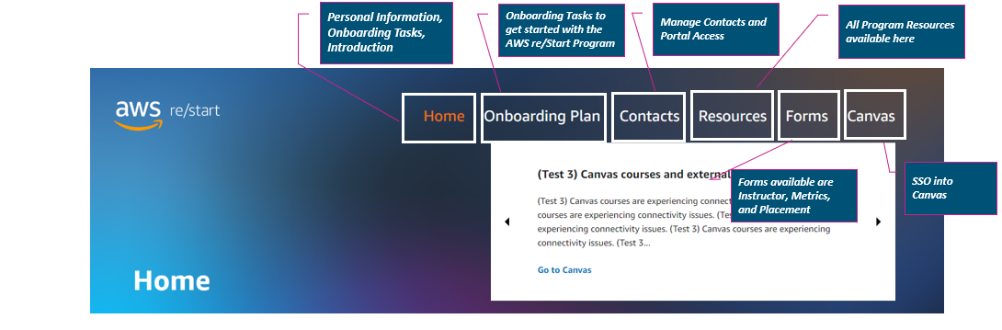

# **How to Reset Your Password**

Before attempting to reset your password, these are the things you should know:

* If the MPOC (Main Point of Contact) has added you as a contact and it has been longer than 7 days since you received the invitation, then you will need to go to <https://support.aws.amazon.com/#/contacts/aws-restart> to request that your password be reset.
* If the MPOC has not added you to the Portal, they need to do this before you set up your password. Please contact the MPOC to add you as a contact.
* Please do not try to log into Canvas directly, as you will receive an error. You will need to Single Sign On (SSO) into Canvas through the Portal after you login.

To get started on resetting your password, login to the AWS re/Start CO Portal [here](https://www.awsrestartprogram.com/).

Then, click on “Forgot Your Password?”

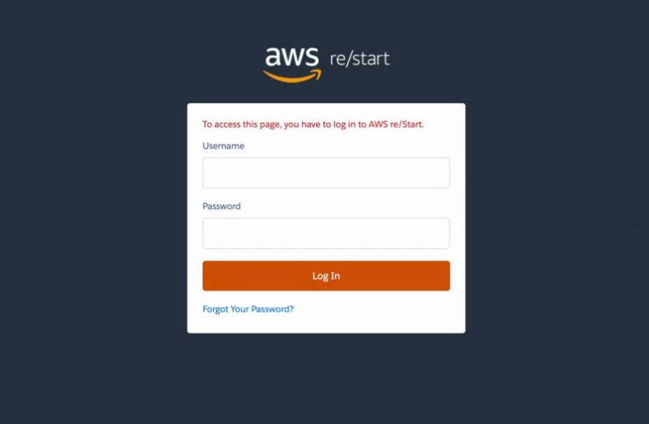

Then, enter your username. Your username is your email address with .awsrestart at the end of it.

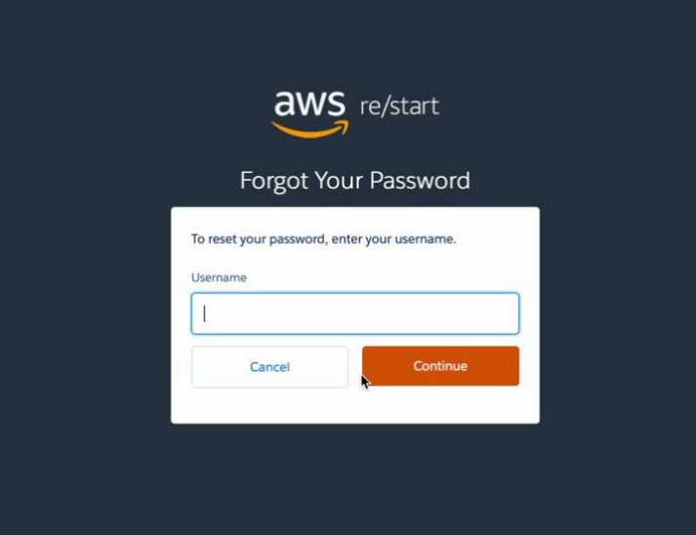

You will then receive an email with instructions to reset your password.

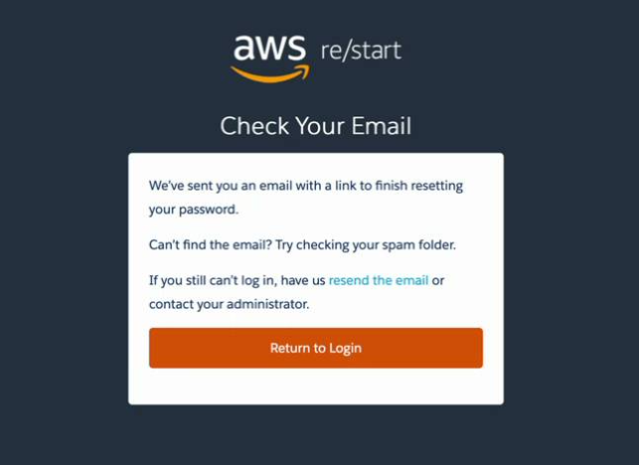

Any issues? Go to <https://support.aws.amazon.com/#/contacts/aws-restart>

# **How to Manage your Contacts**

In this section we review how to manage the contacts within your organization in the AWS re/Start Portal. **Please keep in mind that these actions can only be performed by the main point of contact (MPOC) in the organization.**

**How to EDIT users**

To **EDIT** an existing user, you must be the **main point of contact** for your organization. Click on the  next to the name of the person you want to edit and click on **EDIT**. A screen-pop up appears where you can edit the person’s information.

To **add a role**, click on the role you want to add. To add, click on the arrow icon .

To **remove a role**, click on the role you want to remove. To remove, click on the arrow icon .

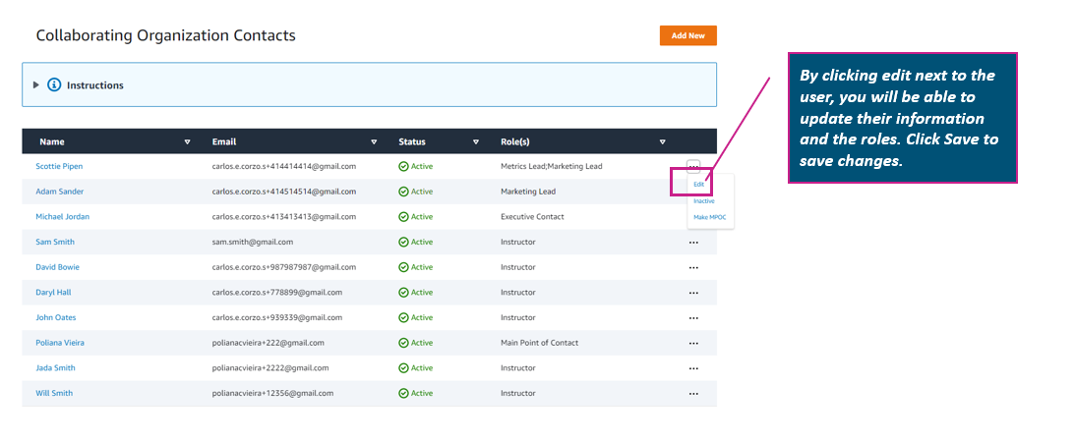

**How to ADD users**

To **ADD A NEW USER** to the portal, you must be the **main point of contact** for your organization. Click on the icon . A screen-pop up appears where you can add that person’s information.

Add the **First Name, Last Name, and email address** of the individual. Please make sure that the email address is correct as that will be the username of the person to login to the portal.

To **add a role**, click on the role you want to add. To add, click on the arrow icon .

To **remove a role**, click on the role you want to remove. To remove, click on the arrow icon .

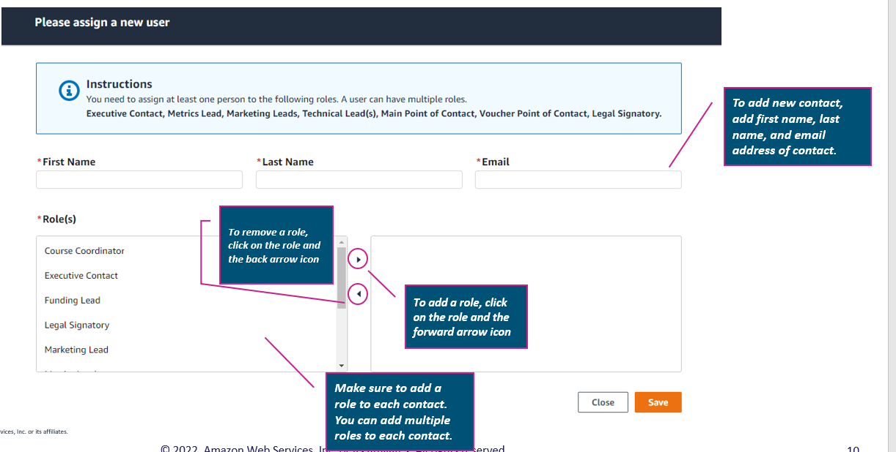

**How to DEACTIVATE a user**

To **DEACTIVATE** an existing user, you must be the **main point of contact** for your organization. Click on the  next to the name of the person you want to edit and click on **INACTIVE**. A screen will appear asking if you’re sure you want to deactivate the selected user? Click **YES** if you’re sure. If not, click **NO**.

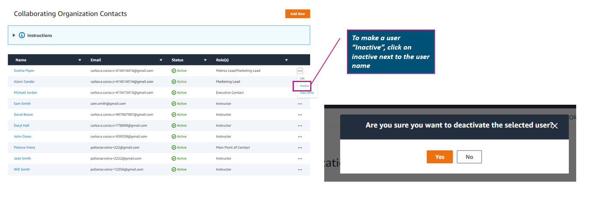

**How to make an existing user a main point of contact**

To make an existing user a **main point of contact**, you must be the **main point of contact** for your organization. Click on the  next to the name of the person you want to edit and click on **MAKE AN MPOC**. A screen will appear asking if you’re sure you want to make that person the **main point of contact** the selected user? Click **YES** if you’re sure. If not, click **NO**.

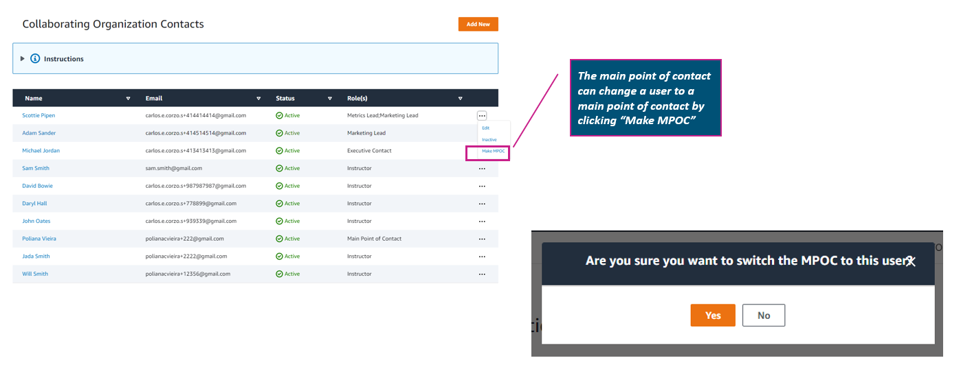

**FAQs**

**What if I’m not the main point of contact for my organization?**

If you’re not the main point of contact for your organization, you will not be able to make any changes to the users in the portal. **Please contact the main point of contact in your organization to make any changes.**

**What about the instructors that already been approved, but not in the contacts list?**

If you have an instructor that has been previously approved and it’s not visible in the contacts list of the portal, please go to <https://support.aws.amazon.com/#/contacts/aws-restart> to request an update on the instructor.

# **How to Submit Instructor Candidates**

1. Login to the AWS re/Start Collaborating Organization Portal [here](https://www.awsrestartprogram.com/)
2. Click on the **FORMS** tab
3. Select **Instructor Candidate** Form
4. Fill out the form to its entirety and click **SUBMIT.**

**Important Information**

* Submit as many candidates as you like using this form. Candidate form is only for **NEW** candidates – If an instructor has already been approved for the organization, they do not need to be approved again.
* If the instructor AWS Certification expires, the Instructor will be labeled as inactive and won’t be able to teach unless they recertify their certification.
* If the instructor leaves the organization, the **main point of contact** can label them as **INACTIVE** in the **CONTACTS** tab of the Portal.

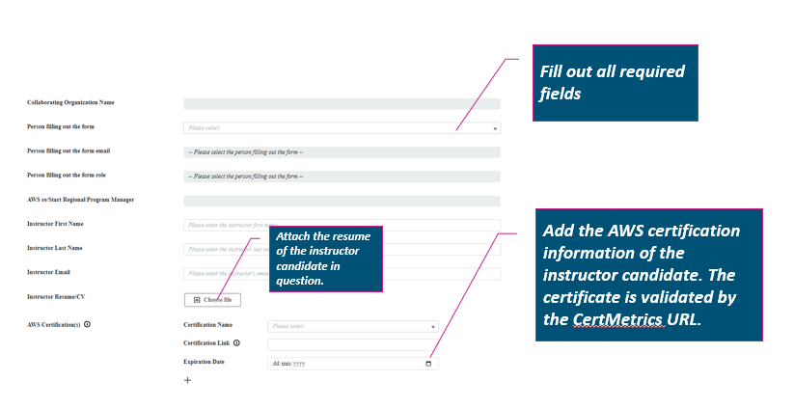

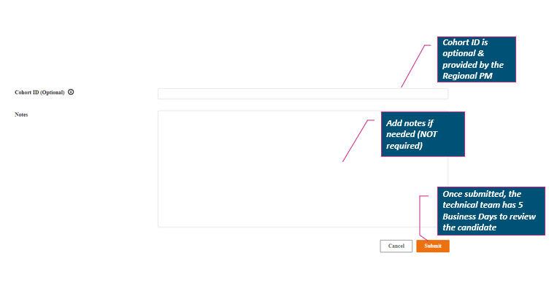

# **Course Coordinator(s) and Professional Skills Instructor(s)**

To make a user a course coordinator and/or a professional skills instructor, you can simply update their role in the AWS re/Start CO Portal under the **CONTACTS** tab. See instructions below. *You must be listed as the* ***Main Point of Contact*** *to follow these instructions*

1. Login through the AWS re/Start CO Portal [here](https://www.awsrestartprogram.com/)
2. Click on **CONTACTS** on the top right corner
3. To **EDIT** a role, click on the  icon next to the name of the person you want to make a course coordinator and/or a professional skills instructor



1. If the name and email address of the course coordinator and/or professional skills instructor is not available in the list of contacts, you can **ADD NEW** to add them to the portal. *Once they have been added, they should receive the email inviting them to the AWS re/Start CO Portal within moments.*



1. To add a professional skills instructor to a class in Canvas, make sure that the class has already been created. Once the class has been created, contact <https://support.aws.amazon.com/#/contacts/aws-restart> using the following template to add them to an existing class in Canvas.
   1. Name of person to be added:
   2. Collaborating Organization:
   3. Cohort ID of existing class in Canvas:
   4. Role of user being added to the existing class in Canvas (*TYPE ONE: COURSE COORDINATOR, PROFESSIONAL SKILLS INSTRUCTOR, INSTRUCTOR).*
   5. Reason as to why they need to be added in the existing class in Canvas:

# **Cohorts Tab**

## Finding the **‘Cohort’** Tab

1. Log in to **CO Portal** using your username (email@xyz.abc.awsrestart) and password
2. Select the **‘Cohort’** tab

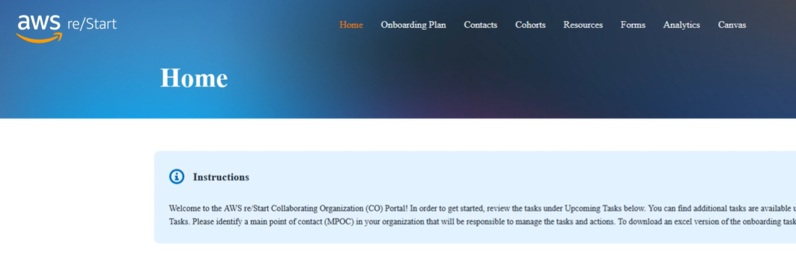

## Finding your Cohorts By Status

### Now that you are in the Cohort tab, you can find your **‘Assigned’**, **‘Committed’**, **‘Ready‘**, **‘Cancelled’** Cohorts

1. Select the picklist that has **‘All status’**
2. Select the **‘Status’** you want to view

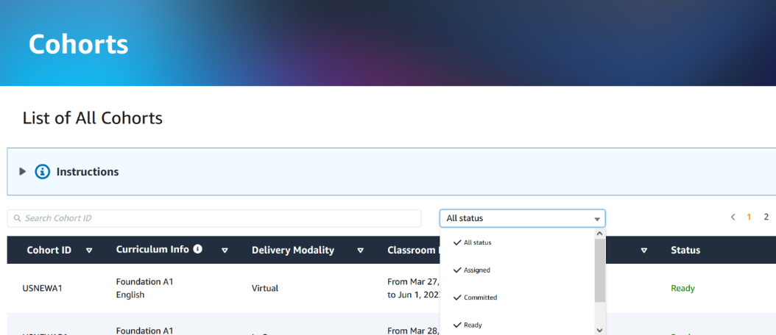

### Adding Instructors and Course Coordinators to the Cohort (MPOC ONLY)

1. Log in to **CO Portal** using your username (email@xyz.abc.awsrestart) and password
2. Select the **‘Cohort’** tab
3. Verify that the **'Classroom Start Date'** and **'Classroom End Date'** field are as expected (if not, please contact your AWS re/Start Regional Program Manager)
4. Select the three dots next to **‘Assigned’** Status
5. Select **'Edit'**

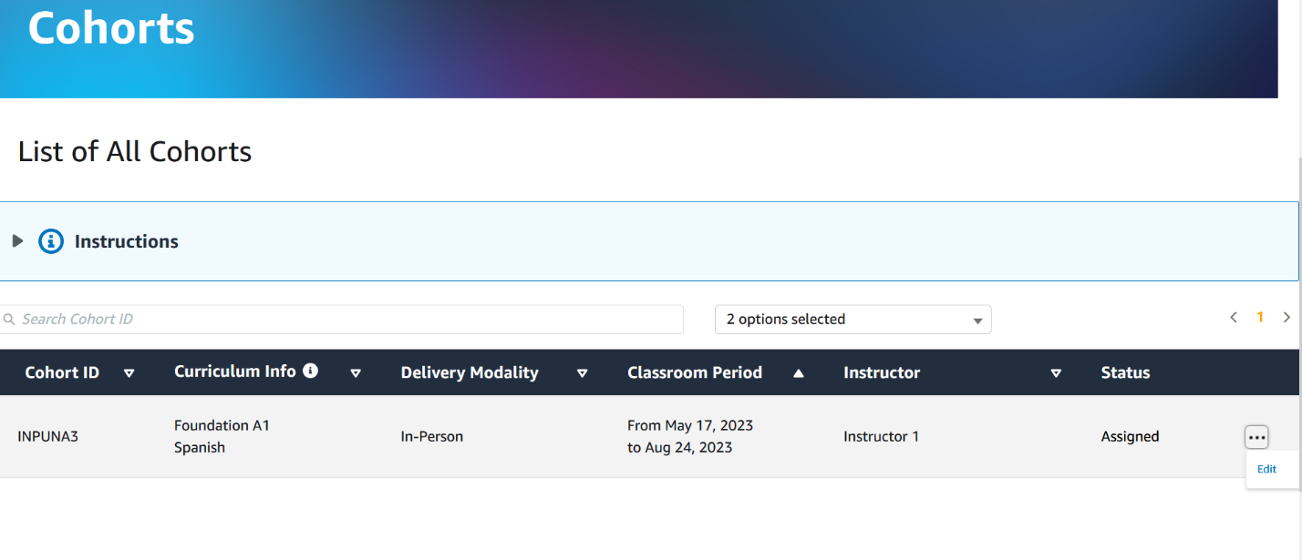

Confirm Classroom Period

1. Select Instructors from the **'Instructor'** picklist (**New!** These will be added automatically to Canvas once you select ‘Committed’).
2. **New!** Select a ‘Course Coordinator’ from the picklist (These will be added automatically to Canvas once you select “Commit”).

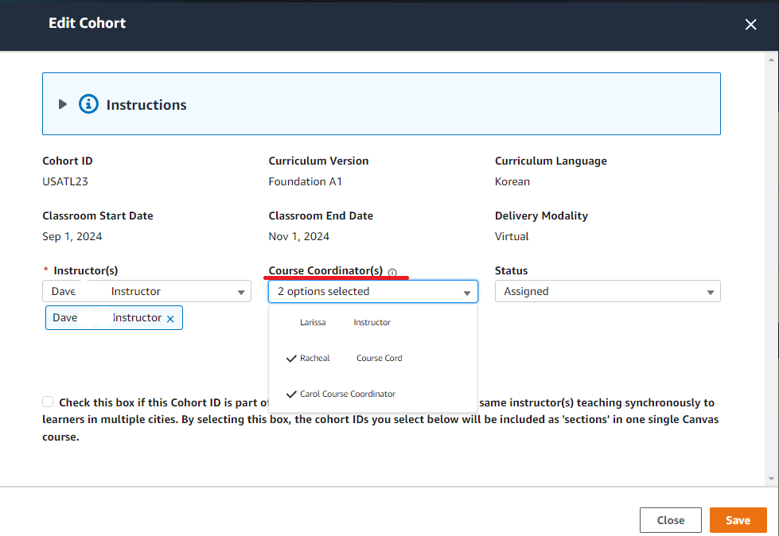

Approved instructors with and valid certification until the classroom end date

### Creating a multi-cohort classroom (MPOC ONLY)

1. **New!** If this is part of a multi-cohort Canvas classroom, associate the multi-cohorts at this stage. In the ‘Edit Cohort’ pop up, you can now associate multi-cohorts with one another. Once users associate the cohorts, they will automatically go under the same Canvas course as multiple sections in the course.

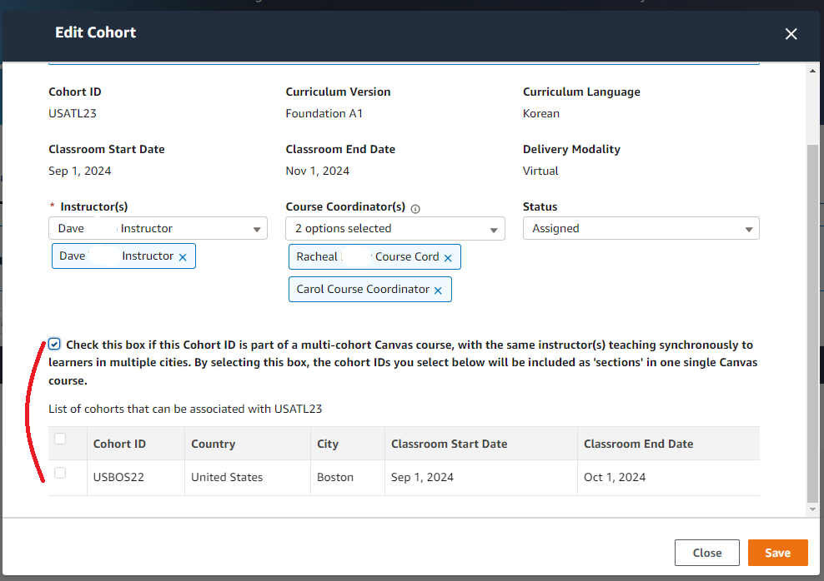

### Committing to a cohort automatically creates a class in Canvas (MPOC ONLY)

1. Change **'Status'** field to **'Committed'**

**New!** NOTE: Once you select “Commit,” if the Instructor is qualified, has taken the Instructor Preparedness Course, and it is at least 14 days from the start date, then the class will be created automatically in Canvas. Therefore, do not select “Commit” until you have selected all of the Instructor/s and Course Coordinator/s you wish to assign to this cohort.

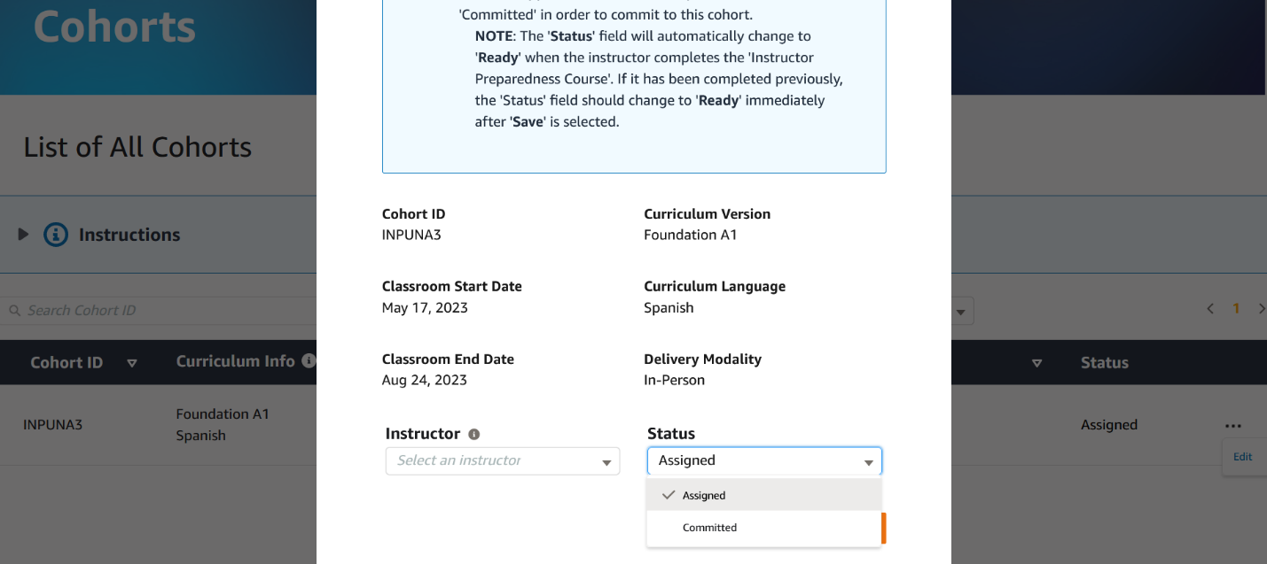

1. Select **'Save'**

**New!** The system will automatically change the status to **‘Ready’** and create the class in Canvas with the selected Instructors and Course Coordinators added automatically (pending that the following conditions are met)*:*

* *Instructor has taken the most recent Instructor Preparedness Course*
* *Instructor’s certification does not expire before classroom end date*
* *Cohort start date is at least 14 days in the future*

If the above conditions are not met, the class will not be created and will remain in **‘Commited’** state.

1. The Instructors and Course Coordinators will receive an email notification once the class has been created. This may take up to 2 hours.

***Context-setting for instructions below:*** Some Collaborating Organizations run remote cohorts to learners in multiple cities. When this takes place, each city is assigned a unique Cohort ID. If you are only running your cohort in one city, you will only have one Cohort ID. If you do not know the Cohort ID, please <https://support.aws.amazon.com/#/contacts/aws-restart>

**How to invite students to a Cohort ID**

1. Click on **“Sections”** tab (second tab at top).
2. Under **“Course Sections”** you will see rows of Cohort IDs (depending on how many locations the course is being delivered to) in the Course. Click on the first Cohort ID to enroll learners who are joining in that location.
3. Click on **PEOPLE** on the left-hand menu bar.
4. Click on the **“+ People”** button on the right-hand side of the screen.
5. Add the email address of the learners who are attending in this location. When adding multiple learners, use a comma **“,”** (not semi-colon **“;”**) or add one email address per line.
6. Under **“Role,”** select **STUDENT**.
7. Under **“Section”**, select the cohort ID that corresponds with the learners listed above.
8. If you want learners to interact with one another across your locations of delivery, do not select**, “Can interact with users in their section only”** (Note that this only applies to the Cohort IDs in this Course). If you do not want students to interact with one another across your cohorts, do select this checkbox.
9. Select **“Next”** to submit the learners to this location.
10. If you have multiple locations within this Course, repeat Steps 4-9

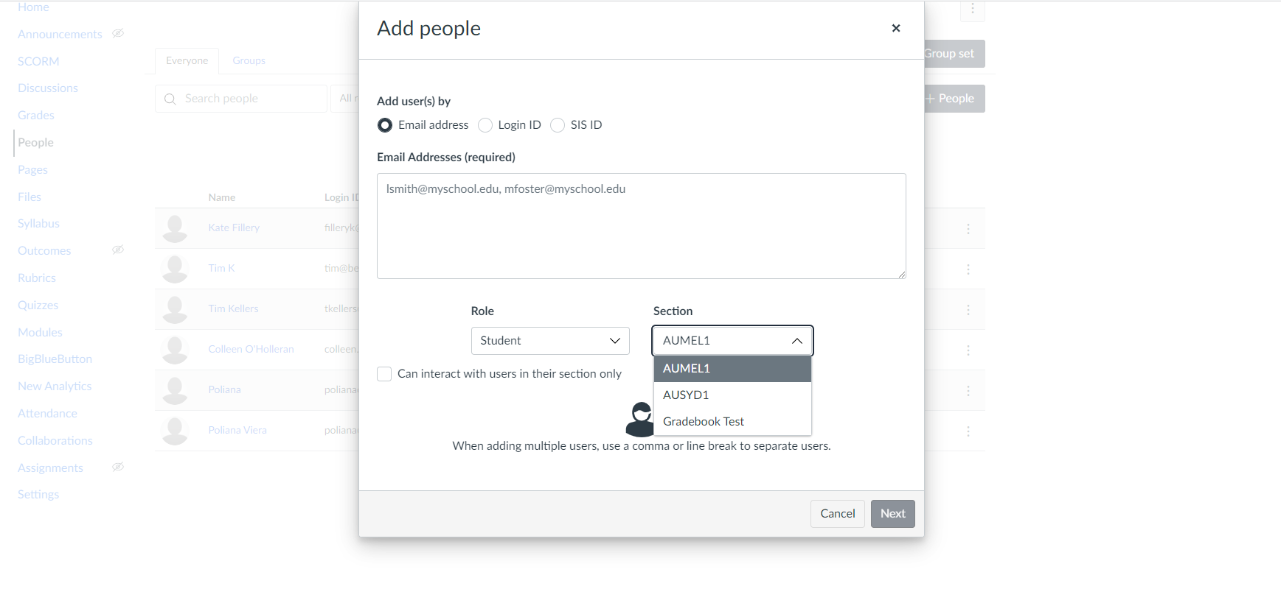

# **Marketing Forms**

**AWS re/Start Marketing and PR form**

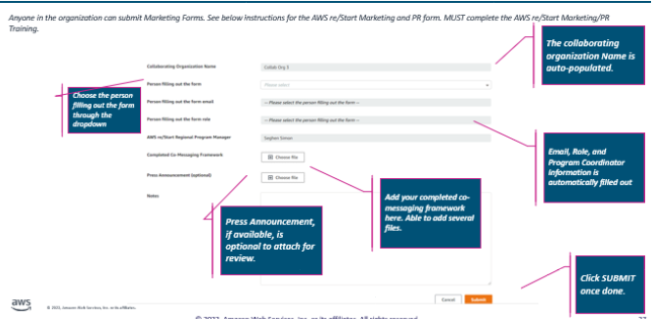

**AWS re/Start Sign-up Link Form**

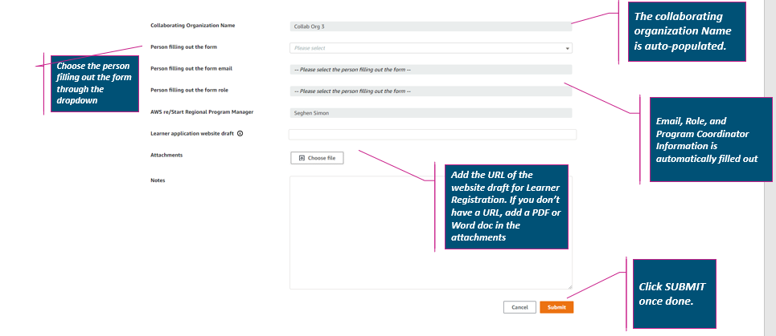

# **How to manage tasks in the AWS re/Start Portal**

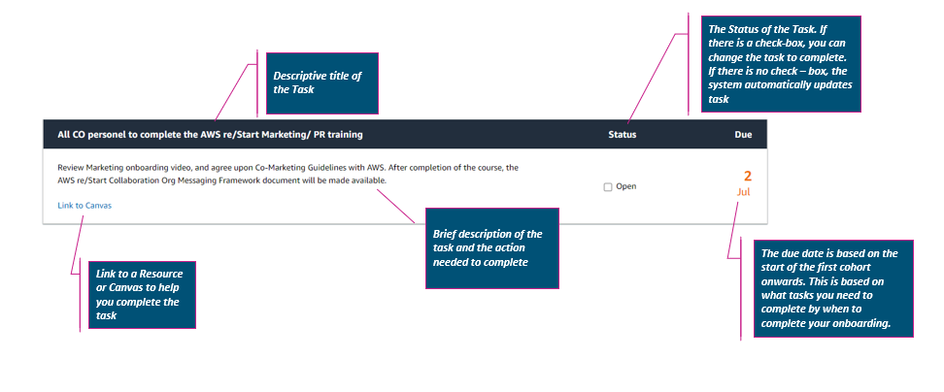

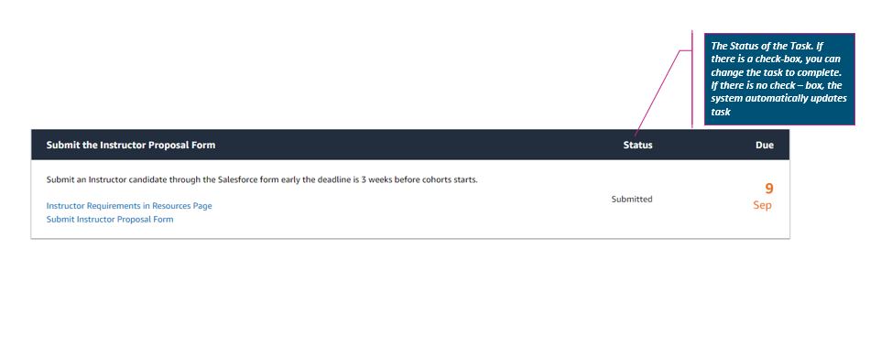

# **AWS re/Start Support**

You can contact AWS re/Start support by going to this link: <https://support.aws.amazon.com/#/contacts/aws-restart>

We encourage you to use the support templates available in the AWS re/Start CO Portal [here](https://www.awsrestartprogram.com/s/resources) – This will expedite the responses to your requests to support, as copying and pasting the content will provide the support team with what they need to respondto your support query. You can find the support templates under the **CORE PROGRAM GUIDANCE** in the **RESOURCES** tab.

# **Delivery Metrics and Placement Data**

**How to submit Delivery Metrics Intake Form**

* Go to **Forms** on the top right-hand side of the AWS re/Start Portal menu
* Click on **Delivery Metrics Intake Survey**
* Fill out the form **ONE** Cohort ID at a time. You only have to fill the form out **ONCE** for each cohort.
* **Cohort ID** becomes available in the Cohort ID dropdown the moment that the class is created in Canvas.
* If you do not see the Cohort ID, it’s likely that something went wrong during the class creation process. Alternatively, if the class started before May 24th 2022, it likely hasn’t been added to the system.
* Fill out the survey **within a week** of the class start date.

*To update any numbers that were submitted or to request a cohort ID to be added to the form, please contact <https://support.aws.amazon.com/#/contacts/aws-restart>.

|  |  |
| --- | --- |
| Field Name | Definition |
| Cohort ID | If you don’t know your cohort ID, please contact your AWS Regional Program Manager |
| Number of Candidates Applied | Number of new candidates’ application in the month for this particular cohort |
| Number of women enrolled (self-reported) | Number of learners who self-reported being a woman for this particular cohort. |
| Total number of enrolled students who did not report gender | Number of learners who did not report gender. All learners must have the option to choose “Prefer Not to Answer”. |
| Number of learners of under-represented minority | Number of learners who self-reported being part of a minority group who started the program for this particular cohort. We understand that some countries don’t allow/don’t capture this information. |
| Total number of enrolled students who did not report ethnicity | Number of learners enrolled who did not report ethnicity or being part of an under-represented minority group. We understand that some countries don’t allow/don’t capture this information. |

**How to submit Placement Data**

* Go to **Forms** on the top right-hand side of the AWS re/Start Portal menu
* Click on **Placement**
* **ONE Leaner = ONE form submission**. This means that for every learner that gets placed from the cohort, one form for each learner needs to be submitted. For example, if 20 people graduated from the cohort and 20 get placed, a form needs to be submitted 20 times.
* If you do not see the Cohort ID, it’s likely that something went wrong during the class creation process. Alternatively, if the class started before May 24th 2022, it likely hasn’t been added to the system.
* To request a cohort ID to be added to the form, please contact <https://support.aws.amazon.com/#/contacts/aws-restart>.

|  |  |
| --- | --- |
| Field Name | Description |
| Job Location Country | Country of the job placement that you’re reporting employment information for |
| Job Location City | City of the job placement that you’re reporting employment information for |
| COD ID | COD ID that you’re reporting employment information for. Should be auto-populated. |
| SIS ID | Should be a dropdown of options based on the COD ID chosen |
| Classroom End Date | Should be auto-populated based on the SIS ID. |
| Employer Name | Name of the employer that hired the AWS re/Start learner/graduate |
| Job Title | Posted job title of the job that the AWS re/Start learner/graduate were hired for |
| Role Type | IT Generalist Technical Support  Customer Support Cloud Engineer DevOps Engineer Platform Engineer Security Engineer Network Engineer Site Reliability Engineer Testing and Quality Assurance Software Engineer or Developer Security Engineer Architect Consultant – Client Facing Technical Sales  Project Administrator Project Manager Business Analyst Other |
| Job Type | Internship Unpaid Internship Paid Apprentice Contract Contract to Hire Part Time Full Time - Hourly Employee Full Time - Salaried Employee |
| Referenceable | Enter ‘Yes’ if the employer information is referenceable. Enter ‘No’ if it’s not. |
| Job Start Date | Start date (mm/dd/yy) of when the AWS re/Start graduate/learner will or have started their job. If the information is not known, add the date that the form is being submitted. |
| Job Connection Source | CO; Individual; Placement Agency; Other |
| Job Wage Rate | The number for the job wage in USD. For example, 20000 is 20,000. |
| Job Wage Period | hourly; per annum; per month; per day |
| Comment | Any additional comments you might have that would be relevant for the regional PMs. If no comments, please add N/A |

# **Analytics Tab**

## Finding the **‘Analytics’** Tab

1. Log in to **CO Portal** using your username (email@email.com.awsrestart) and password.
2. Select the **‘Analytics’** tab.

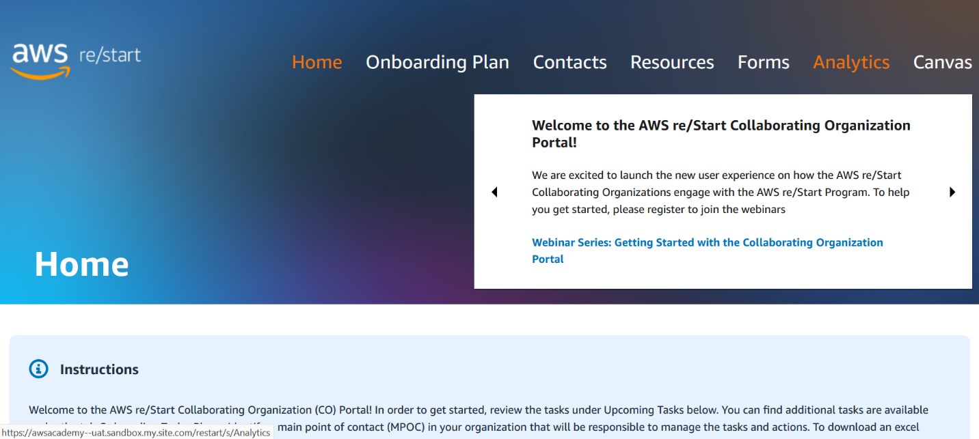

1. Select **‘Delivery Metrics’** to view delivery metrics.

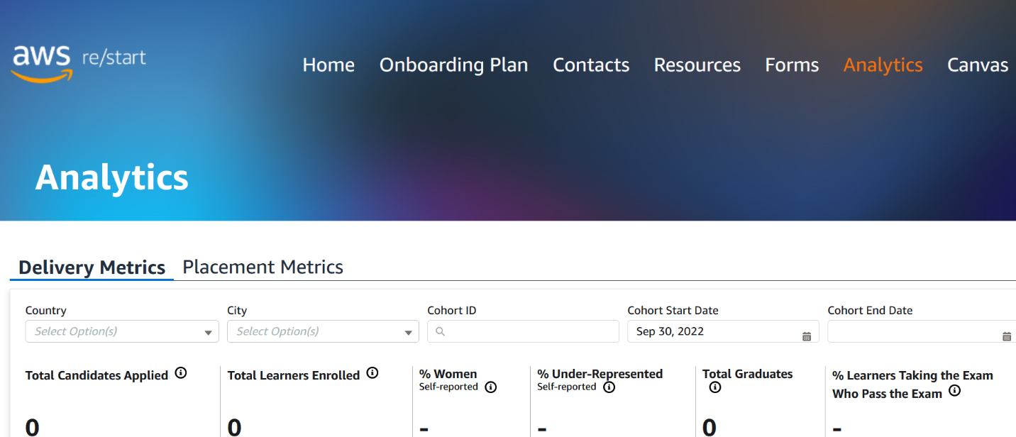

1. Select **‘Placement Metrics’** to view placement metrics.

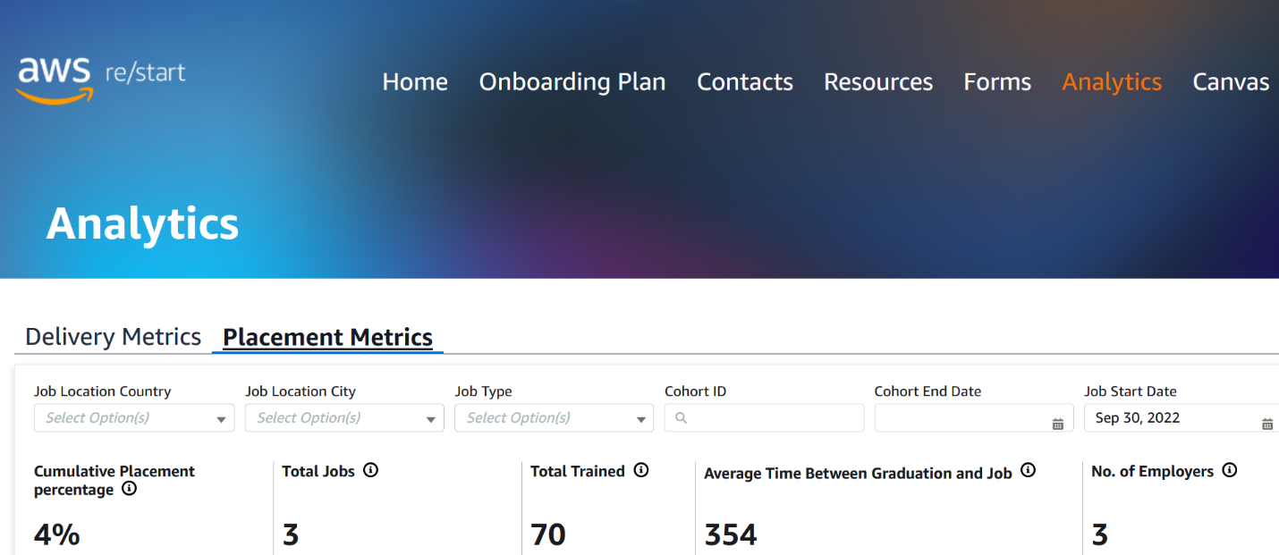

## Using the **‘Delivery Metrics’ and ‘Placement Metrics’**

### Filtering

Filtering helps you view the metrics you need. In the **‘Analytics’** tab, you can filter by many attributes and combine filters to find your metrics more accurately. When filters are applied, the active filters are always displayed.

1. Filter by selecting the attributes desired.

***Delivery Metrics*** *can be filtered by ‘Country’, ‘City’, ‘Cohort ID’, ‘Cohort Start Date’, ‘Cohort End Date’*

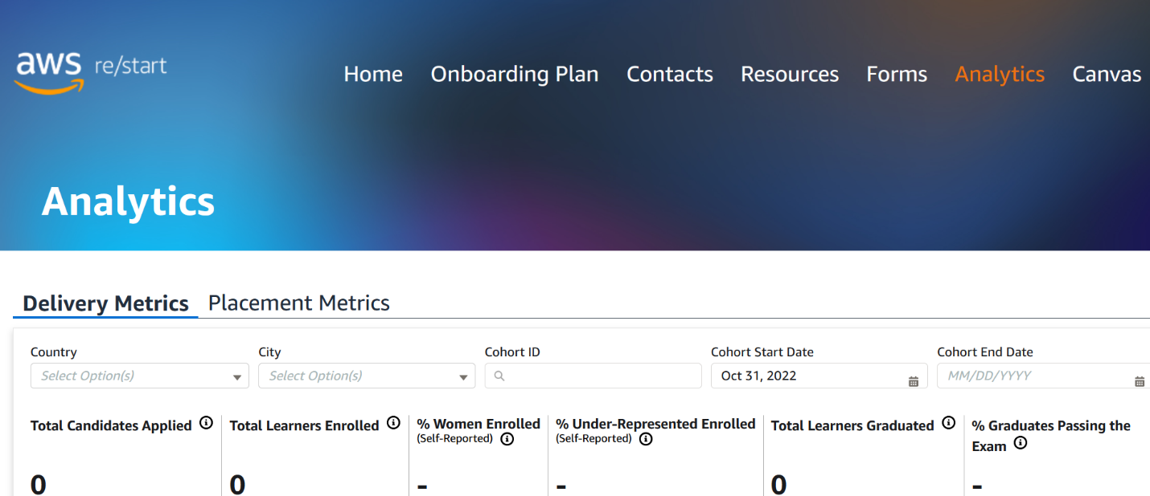

Multiple Countries can be selected

Multiple Cities can be selected

Can search by Cohort ID

Default is set to last day of prior month. Please adjust to see correct metrics

***Placement Metrics*** *can be filtered by ‘Placement Country’, ‘Placement City’, ‘Placement Type’, ‘Cohort ID’, ‘Cohort End Date’, ‘Job Start Date’*

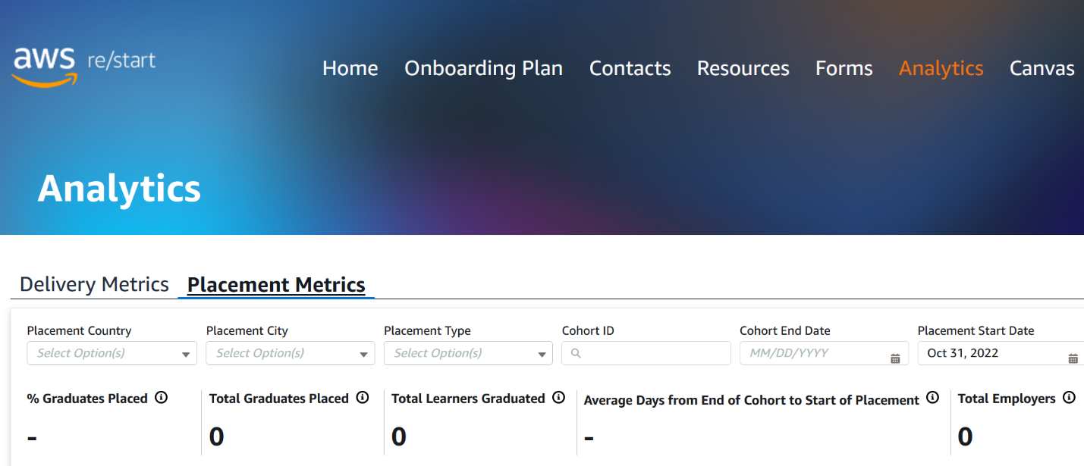

Default is set to last day of prior month. Please adjust to see correct metrics

Multiple Countries can be selected

Multiple Cities can be selected

Can search by Cohort ID

Multiple Job Types can be selected

1. View **‘Metrics Dashboard’** with filters applied.

***Delivery Metrics Dashboard*** *displays ‘Total Candidates Applied’, ‘Total Learners Enrolled’, ‘% Women Enrolled (Self-Reported)’, ‘% Under-Represented Enrolled (Self-Reported)’, ‘Total Leaners Graduated’, ‘% Graduates Passing the Exam’*

Always see active filters

Metrics Dashboard with filters applied

You can scroll right and left to view more metrics

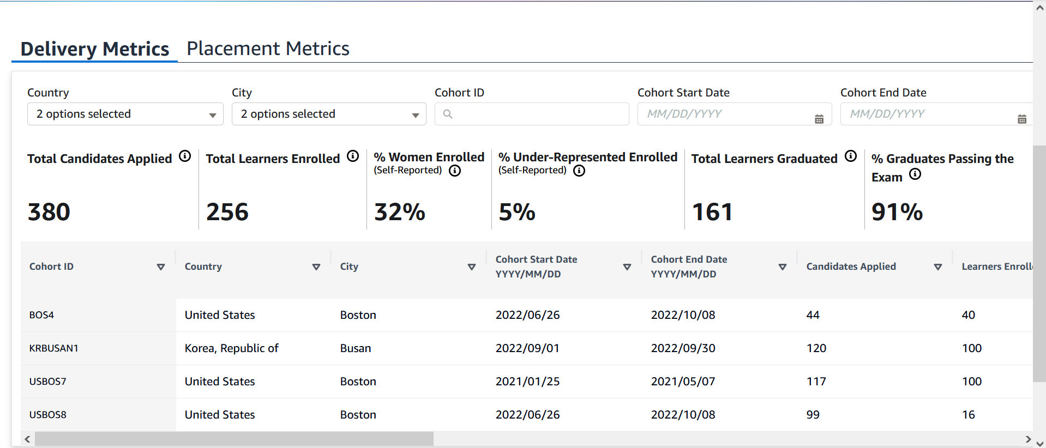

*NOTE: These are not real metrics.*

***YOU MUST contact*** [***https://support.aws.amazon.com/#/contacts/aws-restart***](https://support.aws.amazon.com/#/contacts/aws-restart) ***if you see any errors in your metrics.***

***Placement Metrics Dashboard*** *displays ‘% Graduates Placed’, ‘Total Graduates Placed’, ‘Total Learners Graduated, ‘Average Days from End of Corhort to Start of Placement, ‘Total Employers’*

Always see active filters

Metrics Dashboard with filters applied

You can scroll right and left to view more metrics

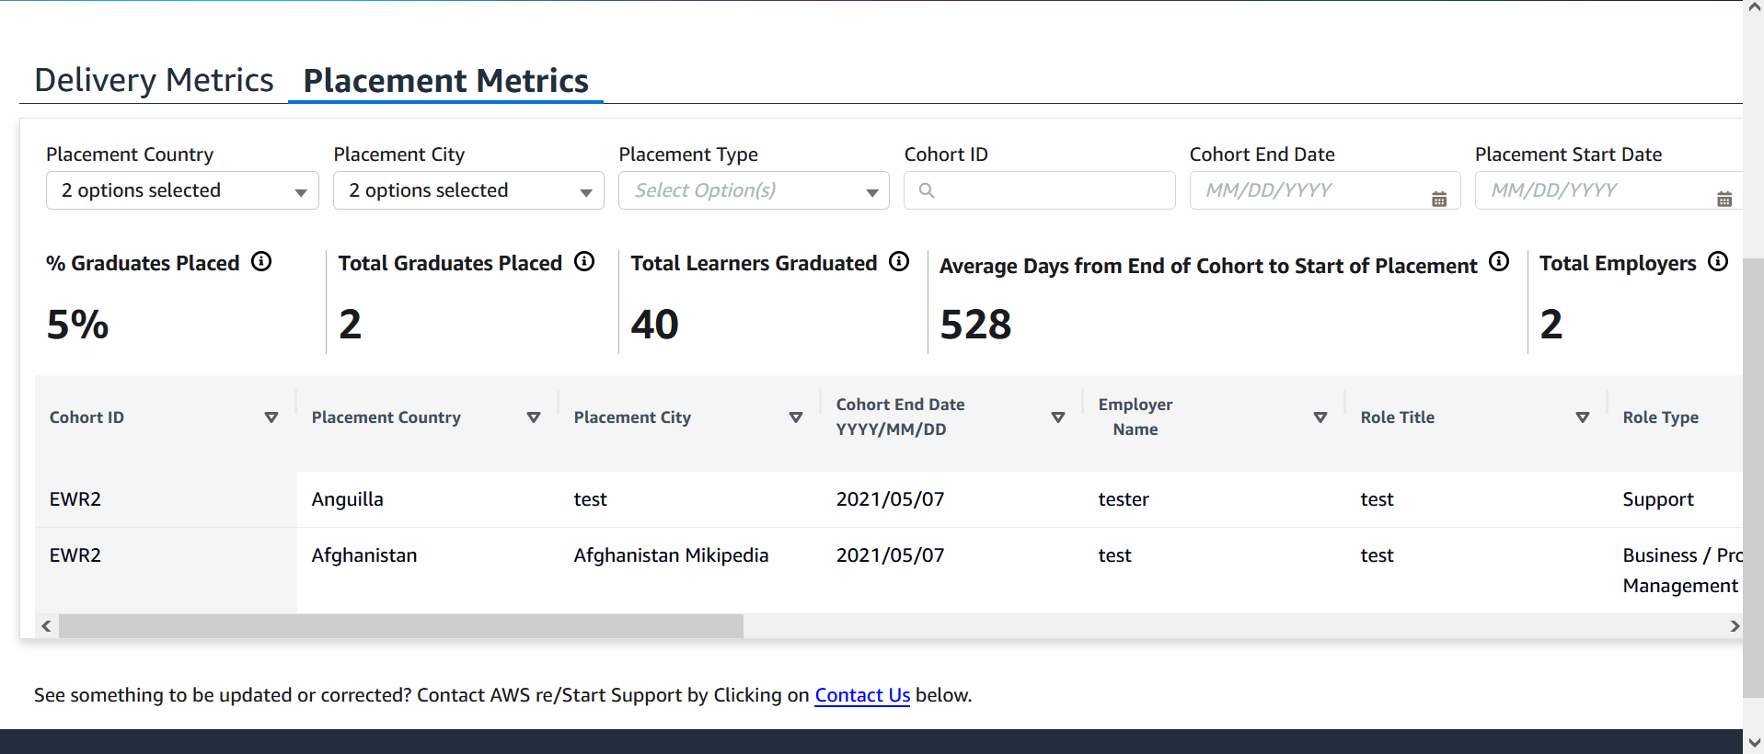

*NOTE: These are not real metrics.*

***YOU MUST email*** [***https://support.aws.amazon.com/#/contacts/aws-restart***](https://support.aws.amazon.com/#/contacts/aws-restart) ***if you see any errors in your metrics.***

### Sorting

Sorting helps you order your metrics so that you can manage them in the proper order. In the **‘Analytics’** tab, you can sort metrics by many attributes. When sorting is applied, the shaded arrow displays the attribute by which tasks are sorted.

*NOTE: The* ***‘Analytics’*** *tab only supports one level of sorting. In sorting tasks by a different attribute, it removes the initial sorting.*

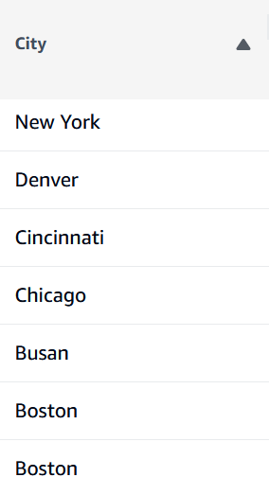

Z to A applied to ‘City’ attribute

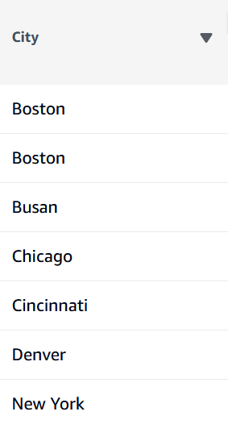

A to Z applied to ‘City’ attribute

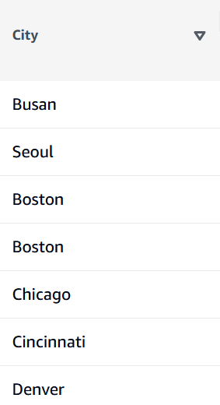

No Sorting applied to ‘City’ attribute

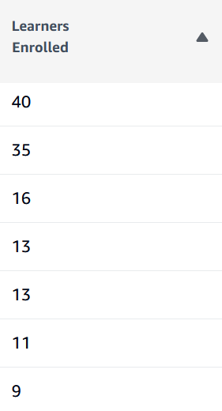

Descending applied to ‘Learners Enrolled’ attribute

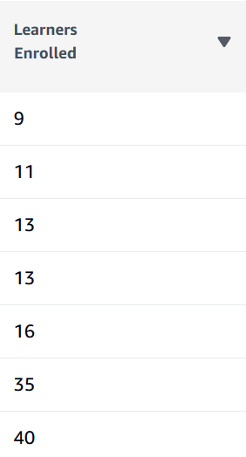

Ascending applied to ‘Learners Enrolled’ attribute

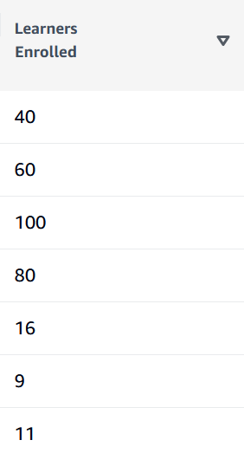

No Sorting applied to ‘Learners Enrolled’ attribute

***Delivery Metrics*** *can be sorted by the following attributes: ‘Cohort ID’, ‘Country’, ‘City’, ‘Cohort Start Date’, ‘Cohort End Date’, ‘Candidates Applied’, ‘Learners Enrolled’, ‘Women Enrolled (Self-Reported)’, ‘Gender Not Reported’, ‘Under-Represented (Self-Reported)’, ‘Under-Represented Status Not Reported’, ‘Certification Exam Passed’, ‘Learners Graduated’, ‘Certification Exam Scheduled’*

***Placement Metrics*** *can be sorted by the following attributes: ‘Cohort ID’, ‘Placement Country’, ‘Placement City’, ‘Cohort End Date’, ‘Placement Start Date’, ‘Employer Name’, ‘Role Title’, ‘Role Type’, ‘Placement Type’, ‘Placement Connection Source’, ‘Placement Wage Rate’, ‘Placement Wage Currency’, ‘Placement Wage Period’, ‘Unique Identifier’*

# **Reporting Issues with Metrics**

***YOU MUST email*** [***https://support.aws.amazon.com/#/contacts/aws-restart***](https://support.aws.amazon.com/#/contacts/aws-restart) ***if you see any errors in your metrics.***

# **Appendix**

## How are the metrics in the Metric Dashboard calculated?

***Delivery Metrics Dashboard***

|  |  |
| --- | --- |
| Metrics | This can be seen by selecting the ⓘ next to the Metrics |
| Total Candidates Applied | The sum of candidates applied is shown in this filtered result. |
| Total Learners Enrolled | The sum of learners enrolled is shown in this filtered result. |
| % Women Enrolled  (Self-Reported) | The cumulative percentage of learners enrolled who self-reported as women is shown in this filtered result (where permissibly legal to report). |
| % Under-Represented Enrolled  (Self-Reported) | The cumulative percentage of learners enrolled who self-reported as being from an under-represented group is shown in this filtered result. |
| Total Learners Graduated | The sum of graduates is shown in this filtered result. |
| % Graduates Passing the Exam | The cumulative percentage of graduates who passed the AWS certification exam is shown in this filtered result. |

***Placement Metrics Dashboard***

|  |  |
| --- | --- |
| Metrics | This can be seen by selecting the ⓘ next to the Metrics |
| % Graduates Placed | The cumulative percentage of graduates who are placed is shown in this filtered result. |
| Total Graduates Placed | The sum of graduates who are placed is shown in this filtered result. |
| Total Learners Graduated | The sum of graduates is shown in this filtered result. |
| Average Days from End of Cohort to Start of Placement | The average number of days from cohort end date to placement start date is shown in this filtered result. |
| Total Employers | The sum of employers that hired re/Start graduates is shown in this filtered result. |

*NOTE: Graduates = Trained and Enrolled = Engaged.*

## Where do the metrics come from?

***Delivery Metrics Dashboard***

|  |  |
| --- | --- |
| Metrics | Where does this come from? |
| Cohort ID | Submission of **‘Create Course’** in Canvas: Cohort ID |
| Country | Submission of **‘Create Course’** Canvas: Country of Delivery |
| City | Submission of **‘Create Course’** Canvas |
| Cohort Start Date  YYYY/MM/DD | Submission of **‘Create Course’** Canvas: Start Date |
| Cohort End Date  YYYY/MM/DD | Submission of **‘Create Course’** Canvas: End Date |
| Candidates Applied | **Delivery Metrics Intake Survey:** Number of candidates applied |
| Learners Enrolled | Students accepted invite to Canvas |
| Women Enrolled  (Self-Reported) | **Delivery Metrics Intake Survey:** Number of women enrolled (self-reported) |
| Gender Not Reported | **Delivery Metrics Intake Survey:** Total number of enrolled students who did not report gender |
| Under-Represented Enrolled  (Self-Reported) | **Delivery Metrics Intake Survey:** Number of learners of under-represented minority (self-reported) |
| Under-Represented Status Not Reported | **Delivery Metrics Intake Survey:** Total number of enrolled students who did not report ethnicity |
| Learners Graduated | Students marked ‘Checkmark with solid fill’ for ‘Graduated’ column in Canvas **Gradebook** as automatically validated by the system |
| Certification Exam Scheduled | Students marked ‘Pass’ for ‘AWS Cloud Practitioner Exam Scheduled’ in **Gradebook** by Instructor or submitted to AWS Customer Support |
| Certification Exam Passed | Students marked ‘Pass’ for ‘AWS Cloud Practitioner Exam Grade’ in **Gradebook** by Instructor or submitted to AWS Customer Support |

***Placement Metrics Dashboard***

|  |  |
| --- | --- |
| Metrics | Where does this come from? |
| Cohort ID | **Placement Form:** Cohort ID |
| Placement Country | **Placement Form:** Job Location Country |
| Placement City | **Placement Form:** Job Location City |
| Cohort End Date  YYYY/MM/DD | **Placement Form:** Classroom End Date |
| Placement Start Date | **Placement Form:** Job Start Date |
| Employer Name | **Placement Form:** Employer Name |
| Role Title | **Placement Form:** Job Title |
| Role Type | **Placement Form:** Role Type Picklist |
| Placement Type | **Placement Form:** Job Type Picklist |
| Placement Connection Source | **Placement Form:** Job Connection Source Picklist |
| Placement Wage Rate | **Placement Form:** Job Wage Rate |
| Placement Wage Currency | **Placement Form:** Job Wage Currency Picklist |
| Placement Wage Period | **Placement Form:** Job Wage Period Picklist |
| Unique Identifier | **Salesforce Interal ID** for submission of Placement Form |